VIP
The diagram shows how instant noodles are manufactured.
Summarize the information by selecting and reporting the main features, and make comparisons where relevant.
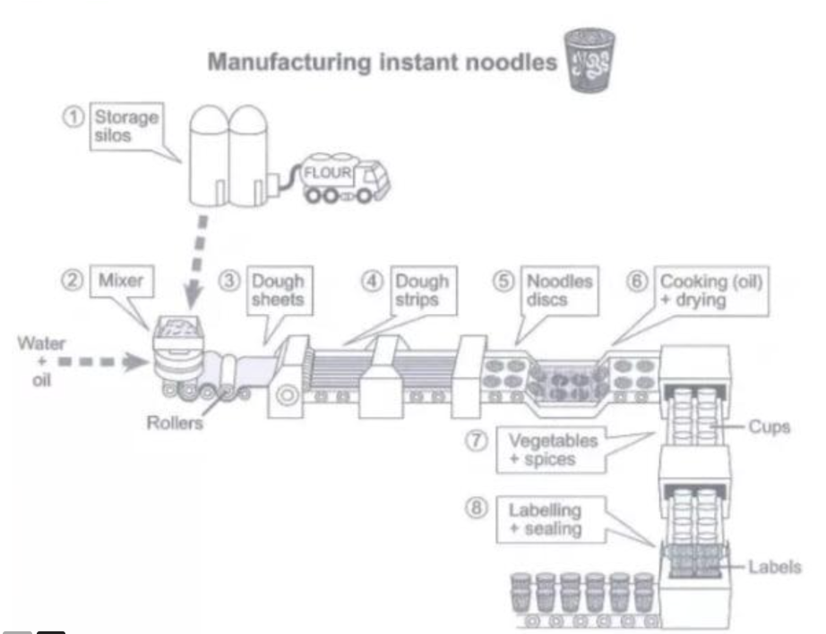
The provided diagram illustrates the sequential stages involved in the manufacturing process of instant noodles.
Overall, the process consists of eight distinct stages, beginning with the storage of flour and ending in final product for commercial distribution, with each stage playing a vital role in aching the final outcome.
A detailed observation indicates that the process commences with flour being stored in silos, after which it is transferred by trucks to a mixing machine where water and oil are added to form a dough. This dough is then flattened into sheets by rollers, and subsequently cut into noodle strips using circular discs.
The shaped noodles are then cooked in oil and dried. Following this, they are transferred to cups, where seasoning—comprising vegetables and spices—is added. The final stages involve labeling the cups and sealing them, preparing the product for retail sale.

